Signature Verification
The Convolutional Neural Network has been used with three ReLU and one Sigmoid layer.

one.ipynb : jupyter work file
home.py : streamlit file with the front page of the overall design
overall.py : Python file to create the overall3.h5 model for all the three languages.
cedar.py : to create the cedar3.h5 model
bengali.py : Python file to create the bengali1.h5 model
hindhi.py : Python file to create the hindhi1.h5 model

The following is the screenshot of the evaluation of the overall3.h5 model:

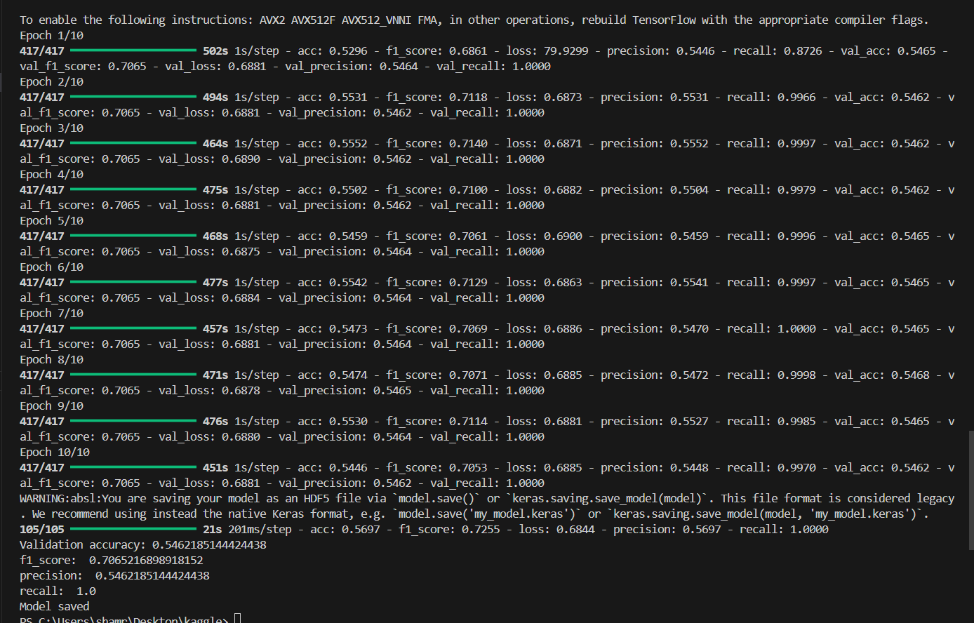

Validation accuracy: 0.546
F1 score: 0.706
Precision: 0.546
Recall: 1.0

The following is the screenshot of the evaluation of the cedar3.h5 model:

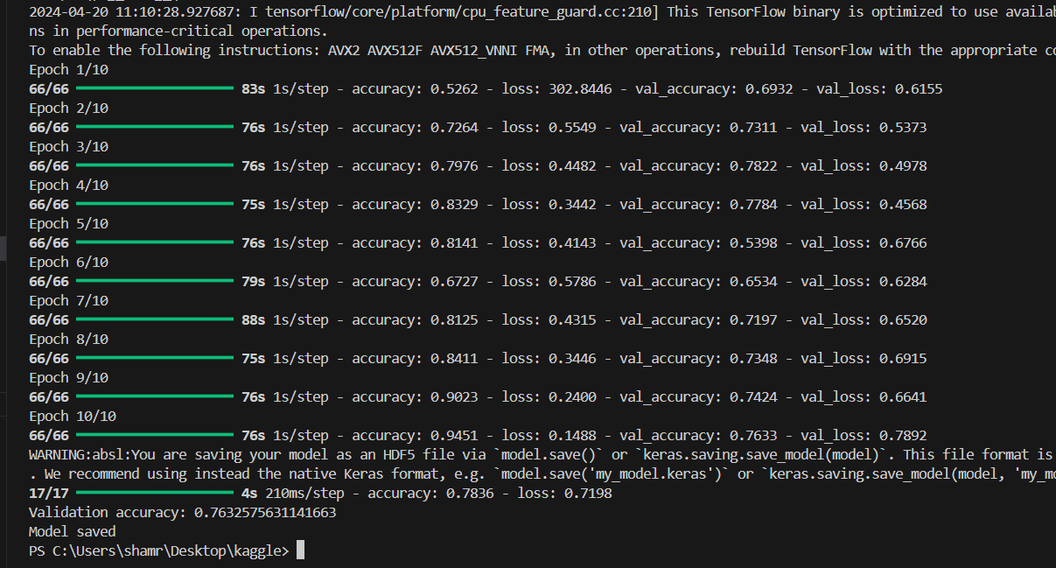

Validation accuracy: 0.7632

The following is the screenshot of validation of hindhi1.h5 model

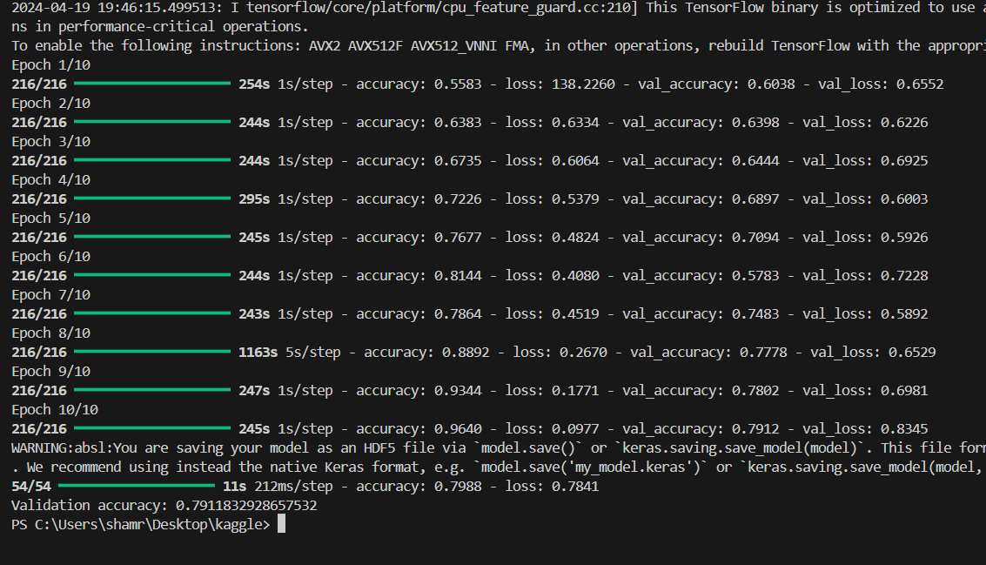

Validation accuracy: 0.791

The following is the screenshot of validation of bengali1.h5 model

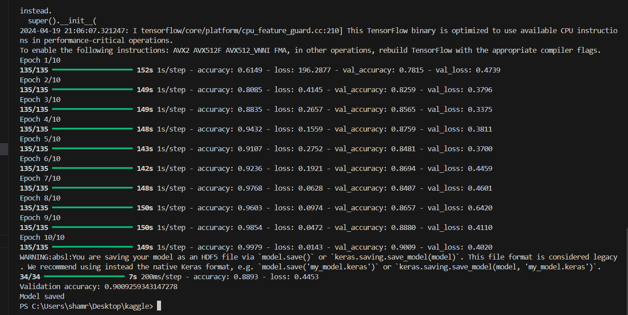

Validation accuracy: 0.9009

